# **Name: Abdurrahman Qureshi**

# **Roll No: 210451**

Practical No: 2

**1) Write a Python program to display your name using Interactive Mode**

**OUTPUT:**

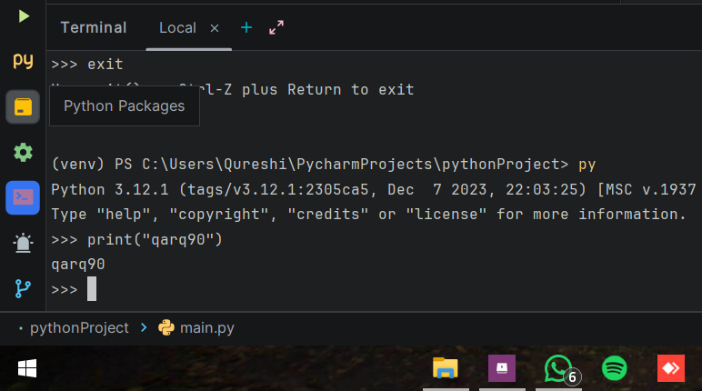

**2) Write a Python program to display “MSBTE” using Script Mode**

**CODE:**

print("MSBTE")

**OUTPUT:**

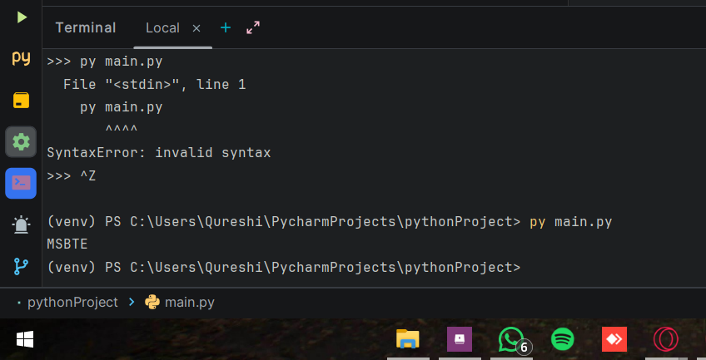

**3) Write a Program to calculate simple interest**

**CODE:**

principle_amount = int(input("Enter Principal Amount: "))  
rate_of_interest = int(input("Enter Rate Of Interest: "))  
time_period = int(input("Enter Time Period: "))  
  
grand_total_amount = (principle_amount * rate_of_interest * time_period) / 100  
  
print("Grand Total: " , grand_total_amount)

**OUTPUT:**

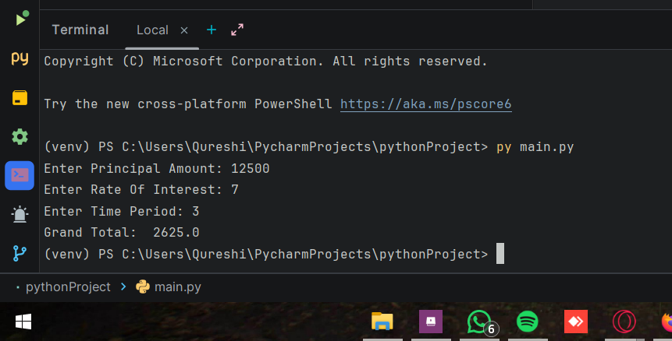

**4) Write a Program to calculate area of rectangle**

**CODE:**

def calculate_area_rect(length,breadth):  
 return length * breadth  
  
  
length = int(input("Enter rectangle Length: "))  
breadth = int(input("Enter rectangle Breadth: "))  
  
area = calculate_area_rect(length, breadth)  
  
print("Area of rectangle: ", area)

**OUTPUT:**

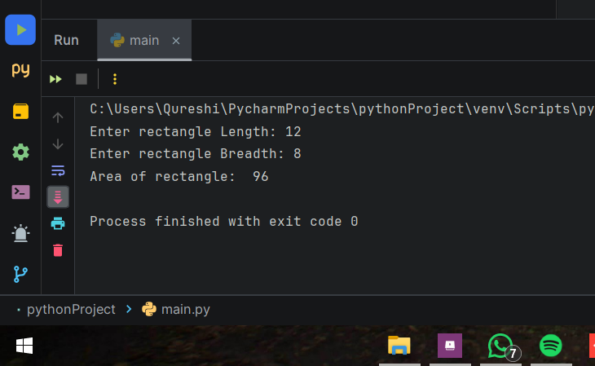

**5) Write a Program to calculate area and perimeter or square**

**CODE:**

def calculate_area_square(len):  
 area = len * len  
 peri = len * 4  
 print("Area of Square: ", area)  
 print("Perimeter of Square: ", peri)  
  
  
length = int(input("Enter Square Length: "))  
  
calculate_area_square(length)

**OUTPUT:**

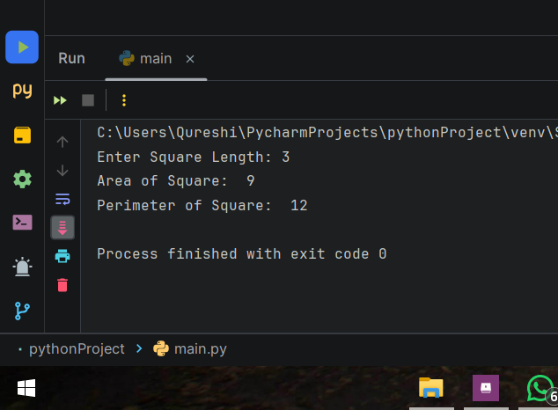

**6) Write a Program to calculate surface volume and area of cylinder.**

**CODE:**

def cylinder_geometry(rad,hei):  
 surface_area = 2 * 3.14 * rad * (rad + hei)  
 print("Surface Area of Cylinder: " , surface_area)  
 volume = 3.14 * rad * rad * hei  
 print("Volume of Cylinder: " , volume)  
  
  
radius = int(input("Enter radius of Cylinder: "))  
height = int(input("Enter height of Cylinder: "))  
  
cylinder_geometry(radius, height)

**OUTPUT:**

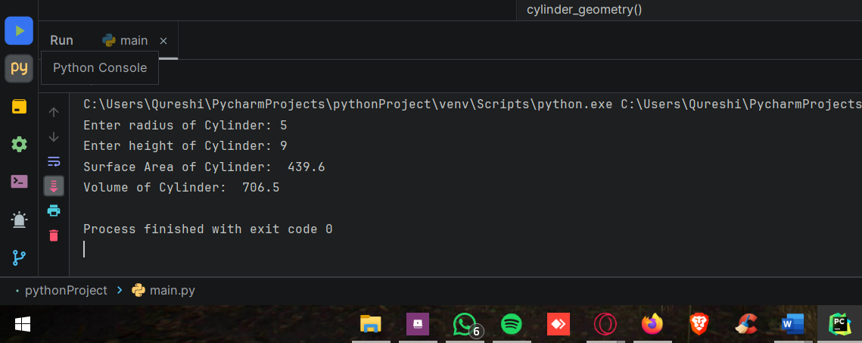

**7) Write a Program to swap numbers without temp variable**

**CODE:**

def swap_numbers(num_a, num_b):  
 print("Numbers ---> Before Swap: [A, B] ", num_a, num_b)  
 num_a = num_a + num_b  
 num_b = num_a - num_b  
 num_a = num_a - num_b  
 print("Numbers ---> After Swap: [A, B] ", num_a, num_b)  
  
  
numX = int(input("Enter number A:"))  
numY = int(input("Enter number B:"))  
  
swap_numbers(numX, numY)

**OUTPUT:**

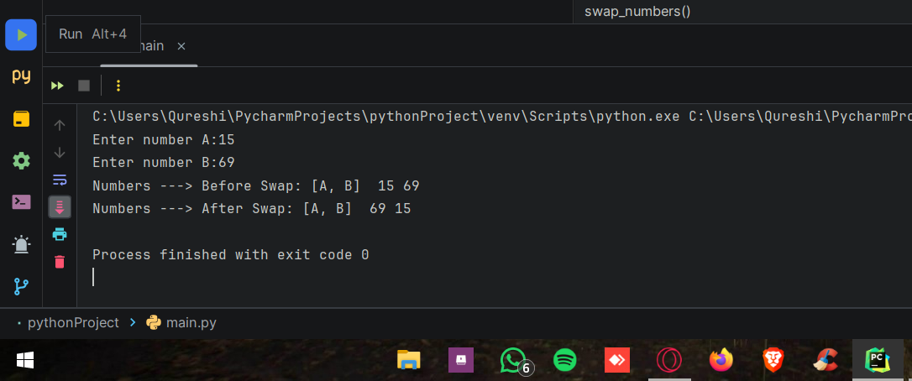

**8) Write a Program to swap numbers with temp variable**

**CODE:**

def swap_numbers(num_a, num_b):  
 print("Numbers ---> Before Swap: [A, B] ", num_a, num_b)  
 temp = num_a  
 num_a = num_b  
 num_b = temp  
 print("Numbers ---> After Swap: [A, B] ", num_a, num_b)  
  
  
numX = int(input("Enter number A:"))  
numY = int(input("Enter number B:"))  
  
swap_numbers(numX, numY)

**OUTPUT:**

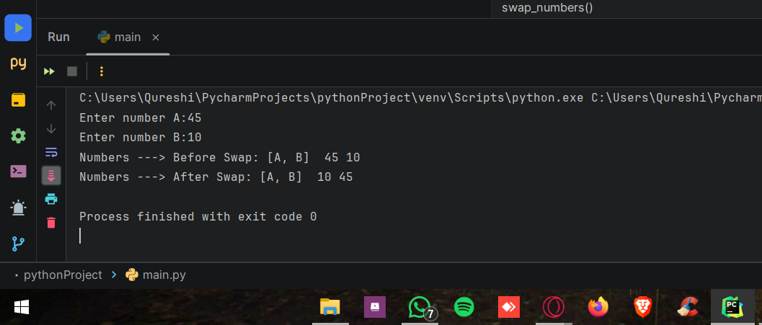

**9) Write a Program to print all datatypes**

**CODE:**

def print_data_types():  
 integer_var = 42  
 print("Integer: ", integer_var, "Type: ", type(integer_var))  
  
 float_var = 3.14  
 print("Float: ", float_var, "Type: ", type(float_var))  
  
 string_var = "Hello, Python!"  
 print("String: ", string_var, "Type: ", type(string_var))  
  
 list_var = [1, 2, 3, 4, 5]  
 print("List: ", list_var, "Type: ", type(list_var))  
  
 tuple_var = (10, 20, 30)  
 print("Tuple: ", tuple_var, "Type: ", type(tuple_var))  
  
 *# Set* set_var = {1, 2, 3}  
 print("Set: ", set_var, "Type: ", type(set_var))  
  
 dict_var = {"key": "value", "number": 42}  
 print("Dictionary: ", dict_var, "Type: ", type(dict_var))  
  
 bool_var = True  
 print("Boolean: ", bool_var, "Type: ", type(bool_var))  
  
  
print_data_types()

**OUTPUT:**

